**COMSATS University Islamabad (CUI)**

*Bachelor of Science in Computer Science*

*(2021-2024)*

Project Report  
(Supermarket Billing System)



***By,***

**Javeria Khan**

**SP21-BCS-032**

***Supervisor,***  
**Dr. Malik Ahmad Kamran**

***Date,***

**06-June-2023**

**Table of Contents**

Contents

Abstract iii

1. Introduction iii

2. Proposed System iii

2.1 Advantages/Benefits of Proposed System iv

3. Scope iv

4. Modules iv

4.1 Module 1: Login iv

4.2 Module 2: Manager v

4.3 Module 3: Cashier v

4.4 Module 6: Product v

4.5 Module 6: Inventory v

4.6 Module 7: Employees v

4.7 Module 9: Supplier v

4.8 Module 10: Customer v

4.9 Module 11: Cart v

4.10 Module 12: Payment vi

4.11 Module 13: Branch vi

4.12 Module 14: Discount vi

4.13 Module 15: Order vi

5. System Limitations/Constraints vi

5.1.1 MongoDB CRUD Operations vii

5.1.2 Front End Screenshots: xi

6. Tools and Technologies xviii

7. DDL Script: xviii

8. Entity Relation Diagram ERD; xxii

xxii

9. Logical Entity Relation Diagram: xxiii

10. User manual xxiv

11. Conclusion xxv

12. References xxv

**Project Category:**

* Desktop Application based Information System

# Abstract

The Supermarket Billing System is a software application designed to automate and streamline the billing process in a supermarket. It aims to provide an efficient and accurate system for managing product inventory, generating bills, processing payments, and maintaining customer records. This document outlines the proposed system, its advantages, and the scope of implementation. The system uses SQL and Java constructs, along with user friendly and easily managed graphical user interface.

# Introduction

The Supermarket Billing System is an advanced software application developed to address the challenges faced in traditional manual billing processes within supermarkets. In the current era of technological advancements, it has become imperative for supermarkets to adopt automated systems that can streamline operations, enhance efficiency, and provide a seamless shopping experience for customers.

The traditional manual billing process in supermarkets involves numerous time-consuming tasks, such as manually entering product details, calculating total amounts, and generating bills. These processes are prone to errors, leading to discrepancies in billing and customer dissatisfaction. Additionally, managing inventory, tracking product availability, and processing payments manually can be overwhelming and inefficiet.Overall, the Supermarket Billing System revolutionizes supermarket operations by introducing automation, accuracy, and efficiency. It empowers supermarkets to meet the demands of the modern retail landscape and deliver a seamless shopping experience to their customers. By adopting this advanced system, supermarkets can optimize their operations, reduce costs, improve customer satisfaction, and stay ahead in the highly competitive market.

# Proposed System

The proposed Supermarket Billing System consists of several database tables to store relevant information. These tables include Product, Inventory, Employee, Manager, Cashier, Supplier, Customer, Cart, Payment, CreditCardPayment, CashPayment, Branch, Discount, OrderDetails, Login, SupplierPhoneNumbers, and DiscountedProduct. Each table has specific attributes and relationships to support the functionalities of the system, such as managing product data, handling inventory, tracking customer details, and processing payments. Develop a supermarket billing system that can manage sales and inventory. Allow cashiers to generate bills for customers quickly and easily. Provide a user-friendly interface for cashiers to use. Maintain an accurate inventory of products in the store. Generate reports for management that can be used to make data-driven decisions.

## Advantages/Benefits of Proposed System

* The system maintains real-time inventory information, allowing supermarket staff to monitor stock levels, track product availability, and generate alerts for low-stock items. This ensures optimal inventory management and reduces the chances of stockouts or overstocking.
* The system generates bills automatically based on the scanned or manually entered products. It calculates the total amount, applies discounts if applicable, and generates an itemized bill for customers. This saves time and simplifies the billing process for both customers and supermarket staff.
* With the Supermarket Billing System, customer information is stored securely in the database. This enables the supermarket to maintain customer records, track purchase history, offer personalized promotions, and provide better customer service.
* The system supports various payment methods, including credit card payments and cash transactions. It accurately calculates change for cash payments and records payment details for future reference. This ensures smooth and reliable payment processing.

# Scope

The scope of this system includes product management, inventory control, billing, payment processing, customer management, and employee management within a supermarket setting. It aims to streamline and automate these processes, providing an integrated solution for efficient supermarket operations. The system can be customized to meet the specific requirements of different supermarkets, ensuring scalability and adaptability.

In conclusion, the Supermarket Billing System offers numerous advantages over traditional manual billing processes. It improves efficiency, accuracy, and customer satisfaction while simplifying inventory management and payment processing. By implementing this system, supermarkets can enhance their operations, reduce errors, and provide an enhanced shopping experience for customers.

# Modules

## Module 1: Login

This module stores information about the login system. It stores the username and password. Manager and Cashier have their own login credentials.

## Module 2: Manager

Manager_id[PK], this module represents the supermarket managers. It includes details about the managers, such as their unique manager_id, name ,email, password and contacts. Manager manages branches and is certainly responsible for inventory management and tract of sales.

## Module 3: Cashier

This module stores the information about cashiers, uniquely identified by Cashier_id[FK]. It saves the Cashier’s name , their employee ID, Email, contacts , their previous experience and password.

## Module 6: Product

This module stores information about supermarket products. It includes details such as the product name, description, and price.

## Module 6: Inventory

This module represents the inventory of products in the supermarket. It keeps track of the quantity of each product available.

## Module 7: Employees

This module contains information about supermarket employees. It includes their first name, last name, email address, and role within the organization.

## Module 9: Supplier

This module contains information about the suppliers of the supermarket. It includes details such as the supplier's ID, CNIC (identification number), and associated employee_id.

## Module 10: Customer

This module represents the supermarket customers. It stores details such as the customer's CNIC, first name, last name, contact information, credit card number and email address.

## Module 11: Cart

This module represents the shopping carts of customers. It stores information about the products added to the cart, along with the quantity and associated order_id.

## Module 12: Payment

This module stores information about payments made by customers. It includes details such as the payment ID, associated order_id, payment date, and payment amount. It further contains payment methods cash or credit card payment.

## Module 13: Branch

This module stores information about the supermarket branches. It includes details such as the branch ID, branch name, location, and associated manager_id.

## Module 14: Discount

This module represents the discounts applicable to supermarket products. It stores information such as the discount ID and discount percentage.

## Module 15: Order

This module contains information about the orders placed by customers. It includes details such as the order ID, quantity, order date, and associated customer_cnic.

# System Limitations/Constraints

This system does not incorporate integration with external systems or online platforms. In today's digital era, it is crucial for supermarkets to have online presence and integrate with e-commerce platforms or mobile applications. This system does not provide the necessary components to support online ordering, online payments, or synchronization with other systems, limiting the supermarket's ability to tap into the potential of online sales channels. The project's database is expected to be of moderate size.

### MongoDB CRUD Operations

**Insertion:**

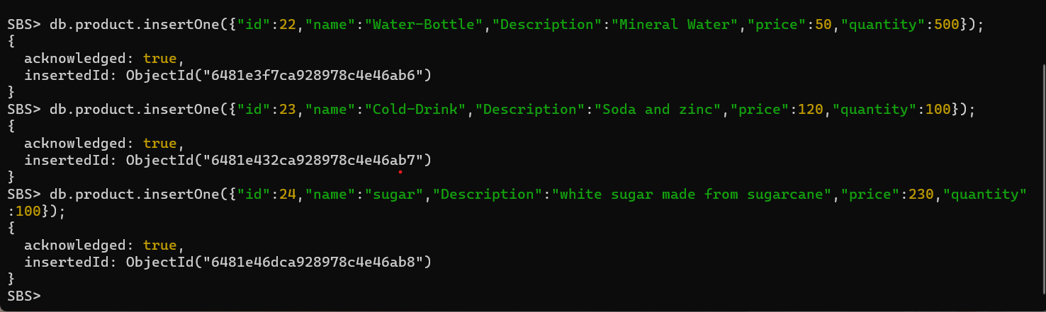

**Cashier.find():**

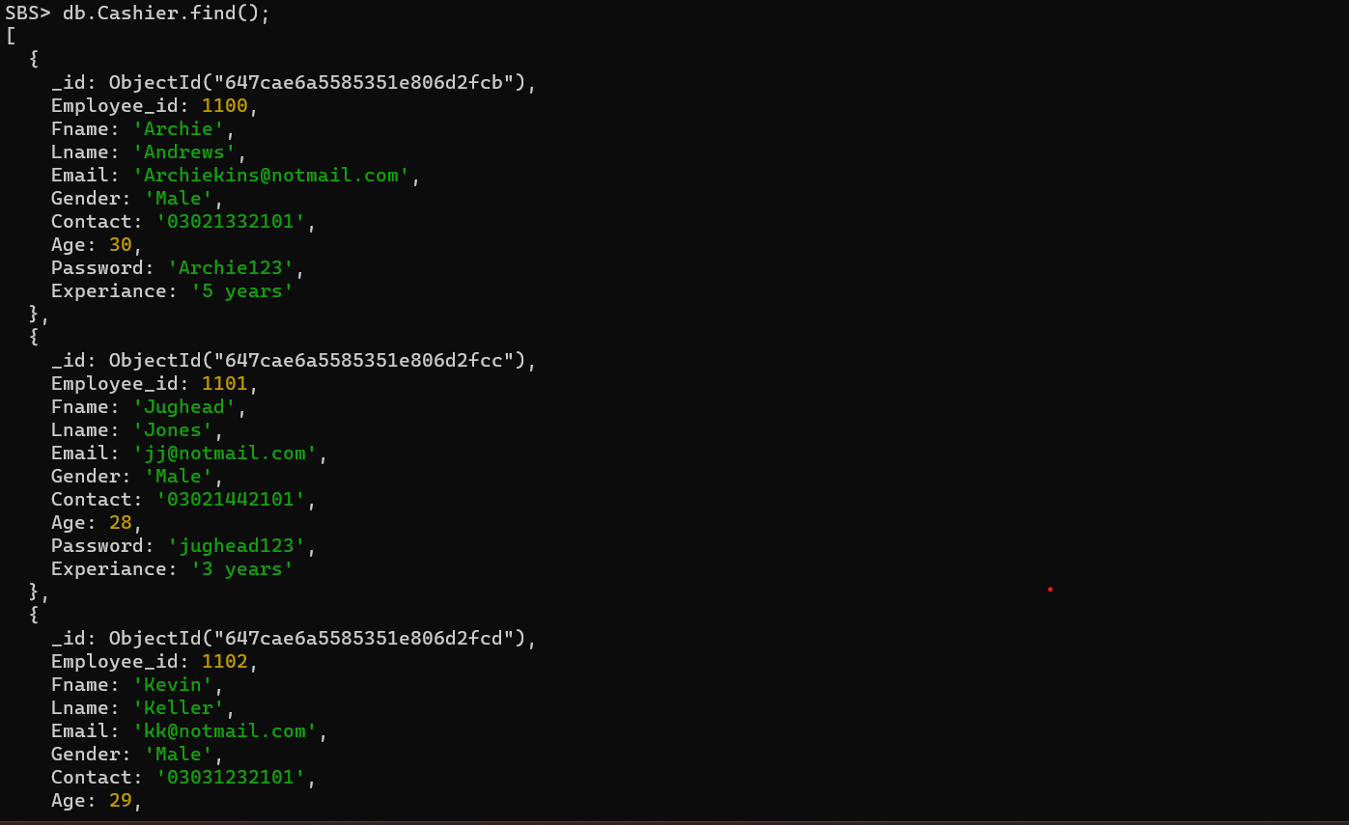

**Product.Find():**

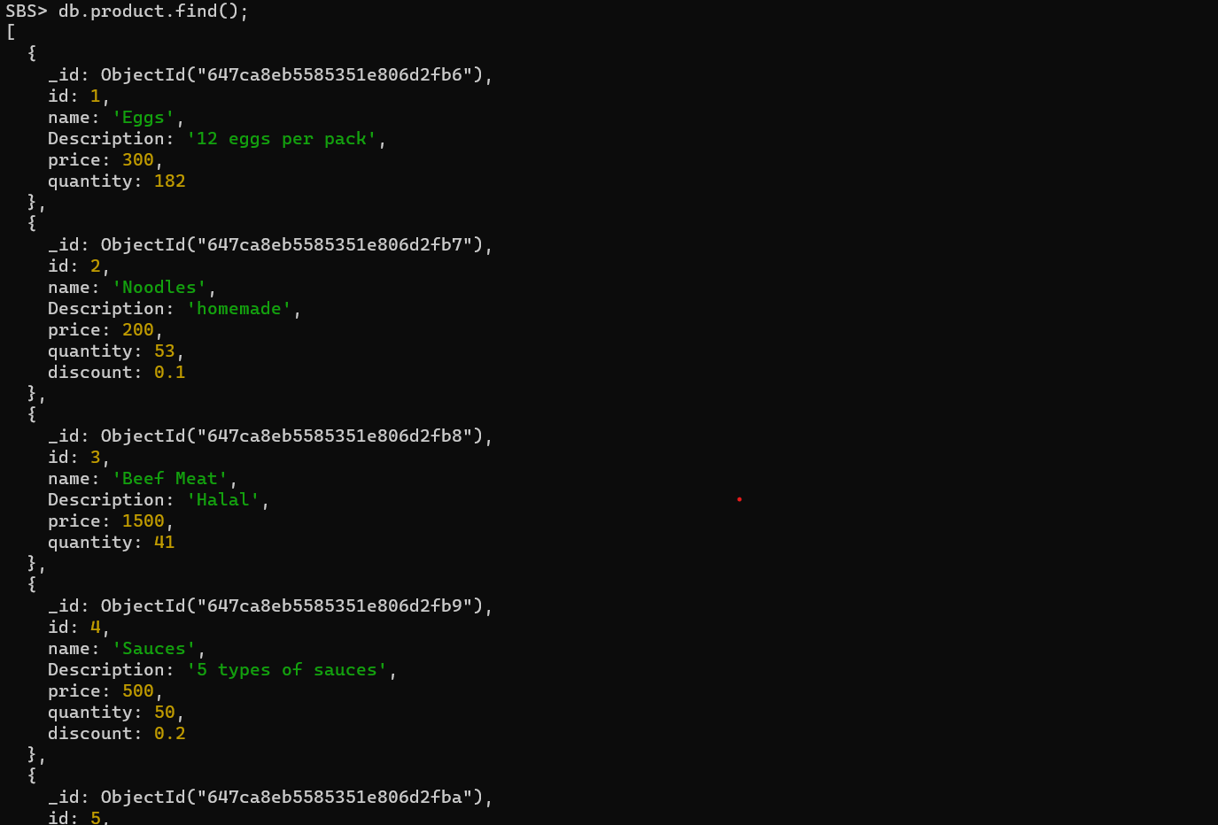

**Manager.find().pretty()**

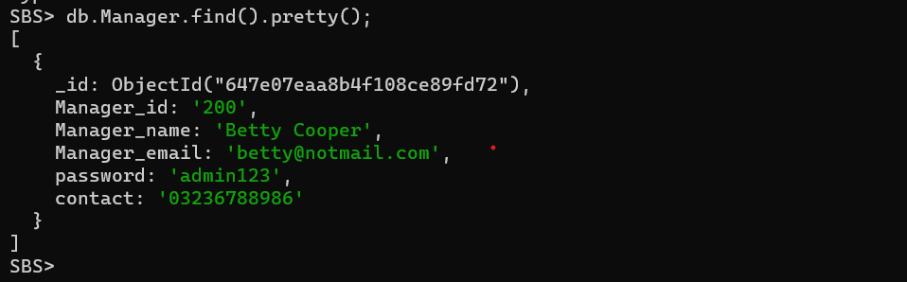

**Db.Cashier.Find({“Fname”:”Jughead”});**

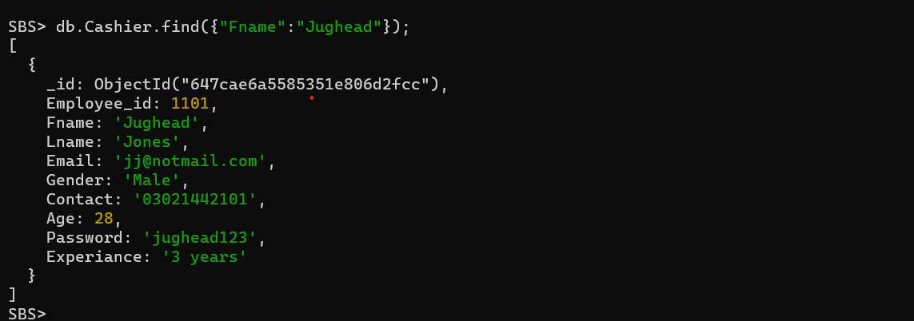

**Insert() and Delete():**

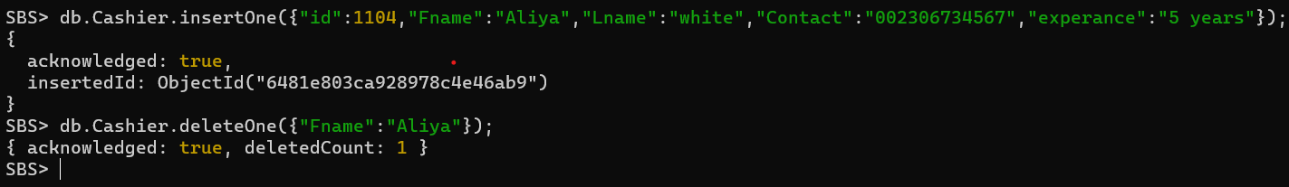

**Less than /Greater than:**

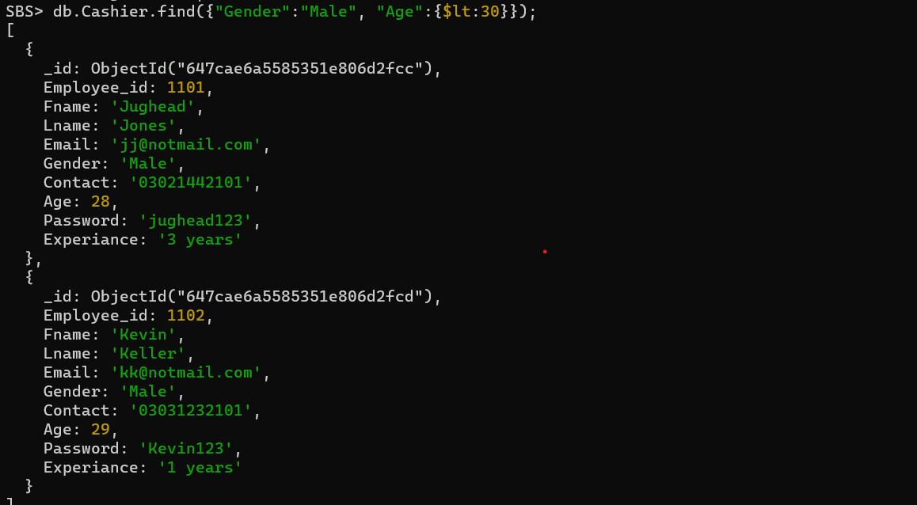

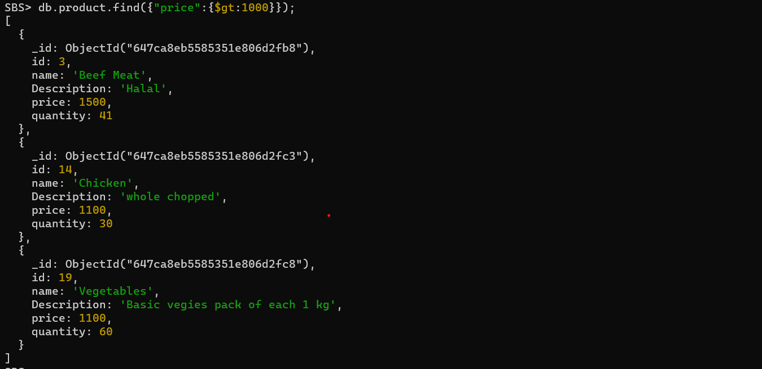

**Aggregation(using $group and $sort):**

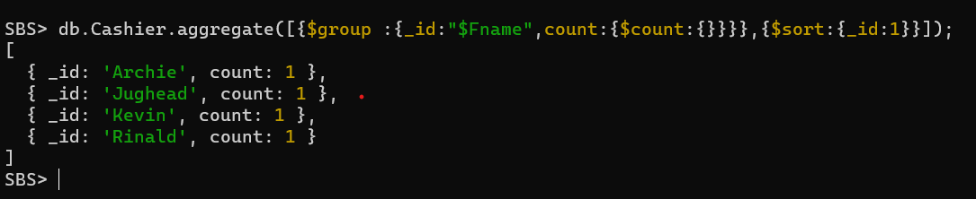

UpdateOne():

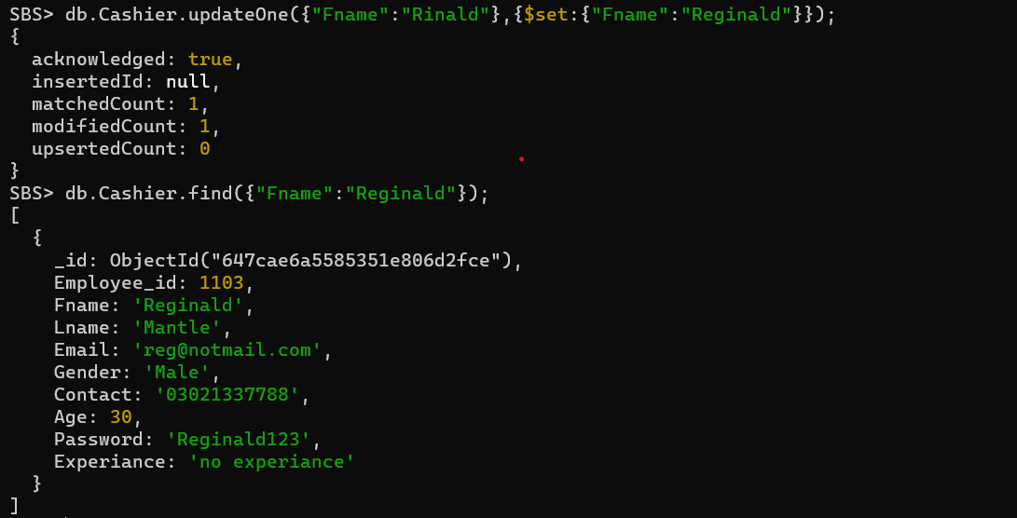

### Front End Screenshots:

**Home Screen**



Login Screen



Manager’s Dashboard









**Add To Cart Screen**



Checkout Screen



**SQL Queries:**

* SELECT product_name,quantity,fname AS supplier_name

FROM Product NATURAL JOIN Inventory NATURAL JOIN supplier

NATURAL JOIN employee;

* SELECT fname,lname,email FROM employee

WHERE employee_id =

(SELECT employee_id FROM manager WHERE manager_id =

(SELECT manager_id FROM branch WHERE branch.branch_name = 'SBS Mart'));

* SELECT product_id,product_name,price FROM product

WHERE product_id = (SELECT product_id FROM product

MINUS

SELECT product_id

FROM DiscountedProduct);

**MongoDB Queries:**

* db.product.insertOne({"id":21,"name":"Apples","Description":"Fresh and green apples","price":350,"quantity":500});
* db.Cashier.find();
* db.product.find();
* db.Manager.find().pretty();
* db.Cashier.find({"Fname":"Jughead"});
* db.Cashier.deleteOne({"Fname":"Aliya"});
* db.Cashier.find({"Gender":"Male", "Age":{$lt:30}});
* db.product.find({"price":{$gt:1000}});

# Tools and Technologies

Table 1: Tools and Technologies for the Targeted Project.

|  |  |  |  |
| --- | --- | --- | --- |
| **Tools**  **And**  **Technologies** | **Tools** | **Version** | **Rationale** |
| Netbeans | 8.2 | IDE |
| Mongo dB Compass | - | Cloud Database |
| MS Word | - | Documentation |
| SQL developer | - | Database |
| **Technology** | **Version** | **Rationale** |
| Java | - | Programming language |
| MongoDB | - | Query Language |
|  | Java swing | - | Framework |

DDL Script:

-- Generated by Oracle SQL Developer Data Modeler 23.1.0.087.0806

-- at: 2023-05-07 12:52:37 PKT

-- site: Oracle Database 11g

-- type: Oracle Database 11g

-- predefined type, no DDL - MDSYS.SDO_GEOMETRY

-- predefined type, no DDL - XMLTYPE

CREATE TABLE Product (

product_id INT PRIMARY KEY,

product_name VARCHAR(255),

description VARCHAR(255),

price DECIMAL(10,2)

);

CREATE TABLE Inventory (

inventory_id INT PRIMARY KEY,

product_id INT,

quantity INT,

FOREIGN KEY (product_id) REFERENCES Product(product_id)

);

-- "Super-class, sub-class" Constraint: Implementing inheritance between Manager and Cashier tables

CREATE TABLE Employee (

employee_id INT PRIMARY KEY,

fname VARCHAR(255),

lname VARCHAR(255),

email VARCHAR(255),

role VARCHAR(20) NOT NULL

);

--overlapping and union implementation

CREATE TABLE Manager (

manager_id INT PRIMARY KEY,

employee_id INT UNIQUE,

FOREIGN KEY (employee_id) REFERENCES Employee(employee_id)

);

CREATE TABLE Cashier (

cashier_id INT PRIMARY KEY,

employee_id INT UNIQUE,

FOREIGN KEY (employee_id) REFERENCES Employee(employee_id),

branch_id VARCHAR(255),

FOREIGN KEY (branch_id) REFERENCES Branch(branch_id)

);

CREATE TABLE Supplier (

supplier_id INT PRIMARY KEY,

supplier_cnic VARCHAR(255),

employee_id INT,

FOREIGN KEY (employee_id) REFERENCES Employee(employee_id)

);

CREATE TABLE Customer (

customer_cnic INT PRIMARY KEY,

fame VARCHAR(255),

lame VARCHAR(255),

contact VARCHAR(255),

email VARCHAR(255)

);

CREATE TABLE Cart (

product_id INT,

quantity INT,

order_id INT,

FOREIGN KEY (order_id) REFERENCES orderDetails(order_id),

FOREIGN KEY (product_id) REFERENCES Product(product_id)

);

--disjoint imlementation

CREATE TABLE Payment (

payment_id INT PRIMARY KEY,

order_id INT,

payment_date DATE,

amount DECIMAL(10,2),

FOREIGN KEY (order_id) REFERENCES Cart(order_id)

);

CREATE TABLE CreditCardPayment (

payment_id INT PRIMARY KEY,

card_number VARCHAR(16),

cardholder_name VARCHAR(255),

FOREIGN KEY (payment_id) REFERENCES Payment(payment_id)

);

CREATE TABLE CashPayment (

payment_id INT PRIMARY KEY,

received NUMBER (15),

change NUMBER(15),

FOREIGN KEY (payment_id) REFERENCES Payment(payment_id)

);

CREATE TABLE Branch (

branch_id INT PRIMARY KEY,

branch_name VARCHAR(255),

location VARCHAR(255),

manager_id INT,

FOREIGN KEY (manager_id) REFERENCES manager(manager_id)

);

CREATE TABLE Discount (

discount_id INT PRIMARY KEY,

discount_percentage DECIMAL(5,2),

);

CREATE TABLE OrderDetails (

order_id INT PRIMARY KEY,

quantity INT,

order_date DATE,

customer_cnic INT,

FOREIGN KEY (customer_cnic) REFERENCES Customer(customer_cnic),

);

CREATE TABLE Login (

login_id INT PRIMARY KEY,

username VARCHAR(255),

password VARCHAR(255),

user_type VARCHAR(255),

employee_id INT,

FOREIGN KEY (employee_id) REFERENCES employee(employee_id)

);

-- "Multi-attribute" Constraint: Supplier has a multi-valued attribute called phone_numbers

CREATE TABLE SupplierPhoneNumbers (

supplier_id INT,

phone_number VARCHAR(20),

PRIMARY KEY (supplier_id, phone_number),

FOREIGN KEY (supplier_id) REFERENCES Supplier(supplier_id) ON DELETE CASCADE

);

CREATE TABLE DiscountedProduct (

product_id INT PRIMARY KEY,

FOREIGN KEY (product_id) REFERENCES Product(product_id),

discount_id INT,

FOREIGN KEY (discount_id) REFERENCES Discount(discount_id)

);

-- Add EER constraints --

ALTER TABLE Manager ADD CONSTRAINT unique_manager_email UNIQUE (email);

ALTER TABLE Cashier ADD CONSTRAINT unique_cashier_email UNIQUE (email);

ALTER TABLE Customer ADD CONSTRAINT unique_customer_email UNIQUE (email);

-- Oracle SQL Developer Data Modeler Summary Report:

--

-- CREATE TABLE 17

-- CREATE INDEX 0

-- ALTER TABLE 3

-- CREATE VIEW 0

-- ALTER VIEW 0

-- CREATE PACKAGE 0

-- CREATE PACKAGE BODY 0

-- CREATE PROCEDURE 0

-- CREATE FUNCTION 0

-- CREATE TRIGGER 0

-- ALTER TRIGGER 0

-- CREATE COLLECTION TYPE 0

-- CREATE STRUCTURED TYPE 0

-- CREATE STRUCTURED TYPE BODY 0

-- CREATE CLUSTER 0

-- CREATE CONTEXT 0

-- CREATE DATABASE 0

-- CREATE DIMENSION 0

-- CREATE DIRECTORY 0

-- CREATE DISK GROUP 0

-- CREATE ROLE 0

-- CREATE ROLLBACK SEGMENT 0

-- CREATE SEQUENCE 1

-- CREATE MATERIALIZED VIEW 0

-- CREATE MATERIALIZED VIEW LOG 0

-- CREATE SYNONYM 0

-- CREATE TABLESPACE 0

-- CREATE USER 0

--

-- DROP TABLESPACE 0

-- DROP DATABASE 0

--

-- REDACTION POLICY 0

--

-- ORDS DROP SCHEMA 0

-- ORDS ENABLE SCHEMA 0

-- ORDS ENABLE OBJECT 0

--

-- ERRORS 0

-- WARNINGS 0

Entity Relation Diagram ERD;

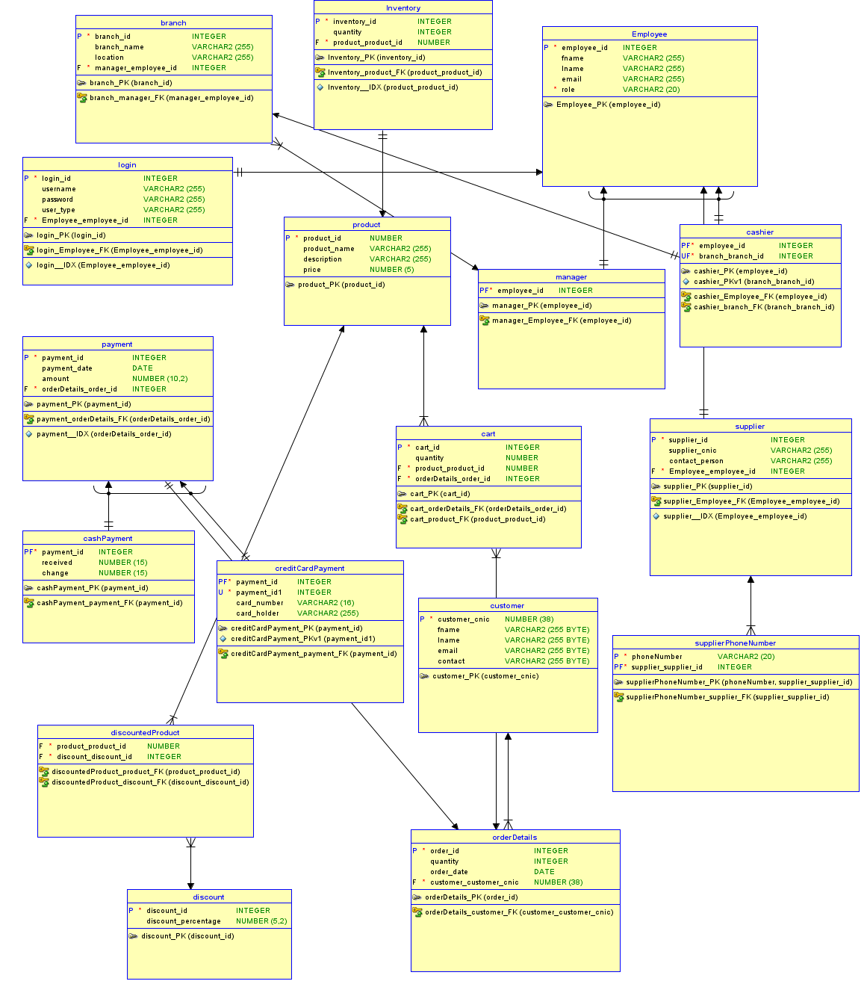

Figure 1: Relational Diagram of Supermarket Management System

Logical Entity Relation Diagram:

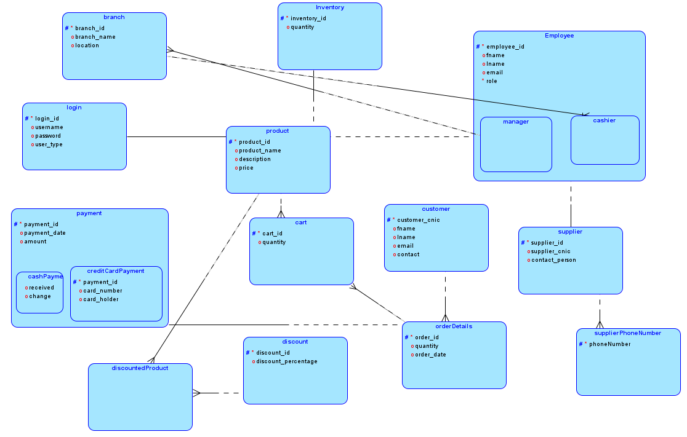

Figure 1: Logical Diagram of Supermarket Management System

# User manual

This project is built in SQL Developer, Data Modeler, MongoDB(no SQL) and Java IDE Netbeans. The database is created in SQL developer and MongoDB, ERD is created in Data Modeler, and application is created in Java. Java is connected to the MongoDB via a jdbc driver. In this application, first the home Screen contains two options, Admin and Cashier, user can enter either of them according to their job by giving specific login credentials. In Admin’s portal, it contains dashboard for managing inventory and cashiers. Manager can Add Cashier, Update Cashier’s information and delete Cashier from the database. Manager can also Add product in the database by its id, price , description and quantity. He can update a specific product by clicking on update product and giving information to update a product. Manager can also delete the product by going into delete option present in dashboard. Logout option is still available for loging out.

Cashier can login through his portal by giving specific login credentials. Then an Add to Screen will appear in which cashier can process the product by its id and quantity, and at end process the payment by giving options of credit card payment or cash payment , cutomer’s name and credit card will also be saved in orders, for future reference. Then a cashier can print a bill for a customer.

# Conclusion

The Supermarket Billing System is a comprehensive solution for efficient and accurate billing processes in a supermarket environment. It enables seamless management of products, inventory, customers, orders, payments, and employee roles. It provides advantages such as streamlined billing operations, improved inventory management, enhanced customer experience, and efficient tracking of sales and payments. However, it has limitations such as scalability challenges and security measures to safeguard sensitive data.

# References

* ([MongoDB Documentation](https://docs.mongodb.com/)).